

INSTALLATION AND USER INSTRUCTIONS

Syn|LERN

**IFB399 – Capstone Project**

Tech Support Contact:

Jonn Dillon

Email: [jonn_dillon@iinet.net.au](mailto:jonn_dillon@iinet.net.au)

Phone: 0404514510

Contents

Installation and User Instructions: 2

Administrators: 2

Install Scrapping OSI Pi: 2

Install Using Window Command Prompt: 3

Requisite software / programs: 3

NodeJS 3

MongoDB Community Edition 3

Git Install instructions: 4

If you have chosen to install git follow these instructions: 4

Database Importing: 5

Admin Functions: 7

Log in: 7

Searching: 8

Adding Content and Quizzes: 9

Manage/Direct/Monitor Users: 10

User Functions: 12

Create an account: 12

Searching: 13

Doing Quizzes: 14

Adding with Comments: 15

Tech Support Contact: 15

### Installation and User Instructions:

The Syn|LERN application is designed to analyse and generate a node tree for an organisations OSI Pi server. An admin may then proceed to populate each node with content information and if so desired, add quizzes assigned to topics. An admin can then direct users to content pages and courses and edit user status and details. As a user, a user can view the node tree labelled “Syn|Tree”, search for a node in the navigation bar, read up on content, add comments to content and take quizzes where available.

### Administrators:

As an admin, you can scrap an OSI Pi to automatically generate a systems node tree or you can manually import through Windows Command Prompt. For ease of use, (as a QUT examiner, we ***STRONGLY*** recommend this) we have set up an example of the application in operation at:

www.synlern.com

Using the login credentials:

For Admin:

User Name: admin

Password: admin

For User:

Username: user

Password: user

***Please proceed to page 7 of this user manual.***

### Install Scrapping OSI Pi:

Scraping of the OSIPI requires set up of the osiPiDetails.ts file find inside the server/src/config folder. 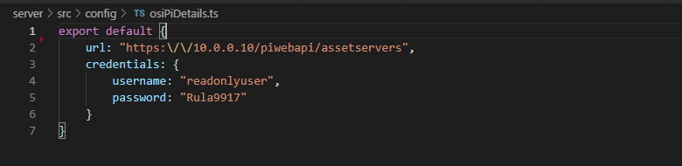

This requires the user to set the details to the OSIPI's endpoint allowing for our software to scrape its data.

To initiate a scape the user needs to be on an admin level account and to access the /api/ url to begin initialisation of the scraping process.

### Install Using Window Command Prompt:

Instructions can be found here: https://github.com/Technosasquach/Capstone_APIPrototype.git

### Requisite software / programs:

If you have never installed this program beforehand, if your using a Mac or Linux machine, you will be able to install almost all of these with Homebrew / package-manager respectively. (Except NodeJS on Mac, with Homebrew I believe)

Installing these though those methods is significantly easier that anything by hand. If you are on windows ensure that all software is mounted to path!, and were possible enable service on start-up! Not doing these can / will cause issues down the line.

NodeJS, Version LTS (12.13.0 at the time of writing). You will want the installer / packaged version, vs the zip version.

Run the Node installer:

* Ensure that Add To Path is going to be 'installed', should be default
* Ensure that you will be downloading the tools to run C/C++ things
* Click install

MongoDB Community Edition, Version 4.2 or greater (252Mb?) Install

Run MongoDB install:

* Agree to everything
* Setup
* Complete Setup or Custom, you want complete
* Service configuration
* Install as a (network service) or local/domain user, just default setting
* Leave as default
* Don't install MongoDB Compass, there are significantly better tools out there
* Click install

Having installed node, you can close the terminal that appears.

### Git Install instructions:

Download / install a method of downloading this repository with a git client, terminal or otherwise. This can be achieved through two ways:

* Using a Git Client like SourceTree, GitKraken, GitHub Desktop, Tower etc, of your choice. Highly recommended
* Using terminal, install git directly onto your machine. Download from this website https://git-scm.com/download

### If you have chosen to install git follow these instructions:

Run the installer

* If you so choose, add a desktop icon. Otherwise leave all settings as is
* Default settings for start folder
* Default editor for git
* Pick whatever you know and feel comfortable with. If you do not recognize any of the programs listed. Then use the default VIM, as it won’t require any extra steps.
* Default selection for PATH variables, should be the one in the middle
* Default to SSL library for security.
* Default selection for check-in / check-out line ending style
* Check out windows, commit Unix
* Picking terminal
* Pick the "Use Windows Default Console Window"
* Default extra options
* Default experimental options
* Install!

Download this repository with the following command / link, into your selected file location (if you don't have folder, make one). The command will need to be run in 'git bash' if you have installed git on windows. Otherwise in terminal on unix systems. If you picked a Git Client, then you only need the https:// url.

git clone https://github.com/Technosasquach/Capstone_APIPrototype.git

Once fully downloaded, all dependencies must be installed. This command should be run inside of cloned repository (./yourFile/Capstone_APIPrototype). Will need to be run in bash / terminal / command prompt (not PowerShell!).

npm install

If it fails to install because it cannot find npm, then you did not mount it to path. Install node again with this option, and restart your terminal

If it fails because of mkdir or permissions. You need to run your command prompt as Admin.

Having fully started, you simply start the application with the command. Will need to be run in bash / terminal / command prompt (not PowerShell!). If you have the same console window open as before, you can just run this command.

npm start

However if you intend to perform development work on the system, then the following command will be more suited to your needs. It auto re-builds both client and server.

npm run watch

If you get a windows defender alert, your windows probably just have sensitive settings.

IF YOU PLAN TO USE THE DATABASE WE HAVE PROVIDED (IT CONTAINS A FULL NODE DB), THEN DO NOT CREATE A USER YET. SKIP TO THE DATABASE IMPORTING SECTION)

In order to access the website. Open your desired web browser and navigate to the site in the URL localhost:3000. You have not used the application, or attached a DB or anything like that, you can create a new user with the 'register now' link.

### Database Importing:

The core repository does not come with a easy way to attach a pre-made database. We have exported a stable and known copy of the DB in the folder ./db. The following lines are the commands required to attach them to your running MongoDB instance.

Each of these lines must be run individually! You cannot copy and paste this whole block.

If you are using a Windows machine, then you will need to install these a bit differently to how you might expect. The MongoDB instance that you installed, is currently running in the background. You will need to run the correct script / bash / terminal deep inside your machine. The following directory is where it should be located if you have installed everything as described above, to defaults.

C:\Program/ Files\MongoDB\Server\4.2\bin\

The next step is you want to prepare these commands to work

mongoimport --db synlern --collection users --file ./db/users.json

mongoimport --db synlern --collection nodes --file ./db/nodes.json

mongoimport --db synlern --collection information --file ./db/information.json

mongoimport --db synlern --collection comments --file ./db/comments.json

mongoimport --db synlern --collection quizzes --file ./db/quizzes.json

mongoimport --db synlern --collection courses --file ./db/courses.json

mongoimport --db synlern --collection accounts --file ./db/accounts.json

Note: There is a potential error where the field size of JSON for the nodes.json file.

### Admin Functions:

### Log in:

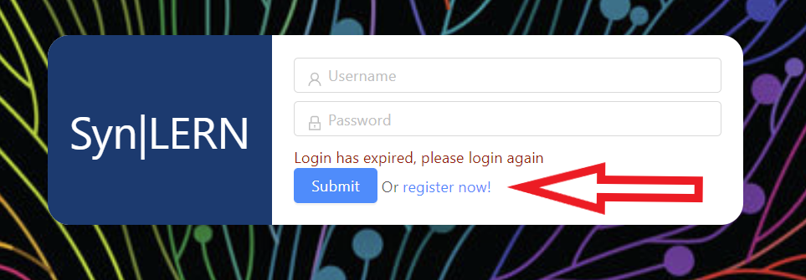

For new users select “register now!”.

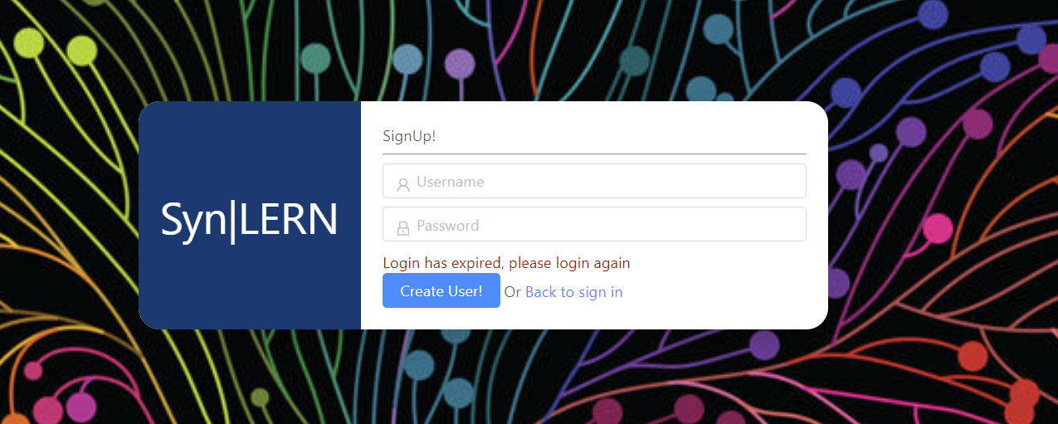

Add user name and password and click “Create User”.

### Searching:

Select “Syn|Tree”, navigate node tree using left muse click and scroll wheel, to find a node (or topic) of interest.

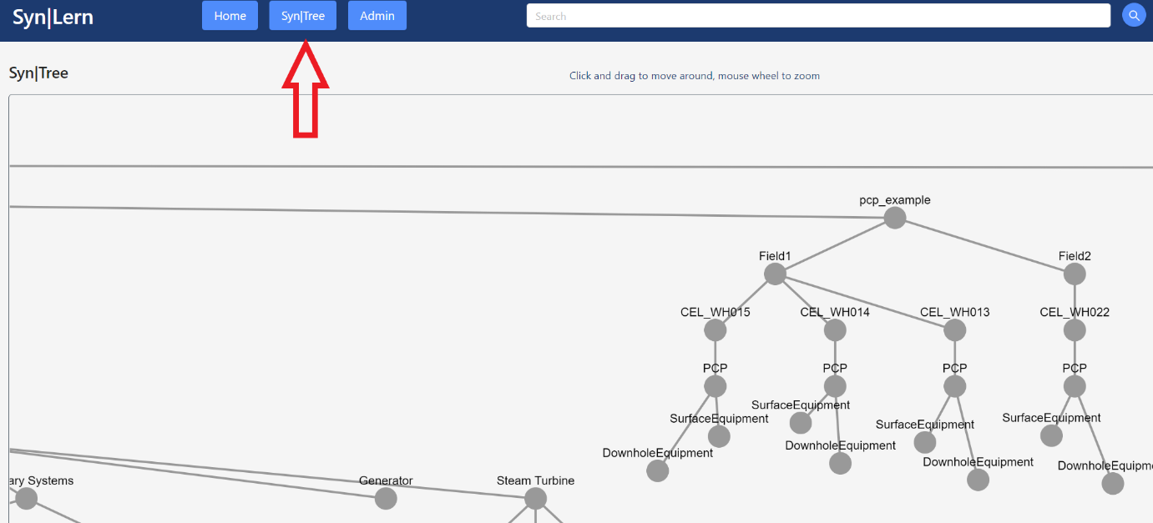

Enter topic into search bar.

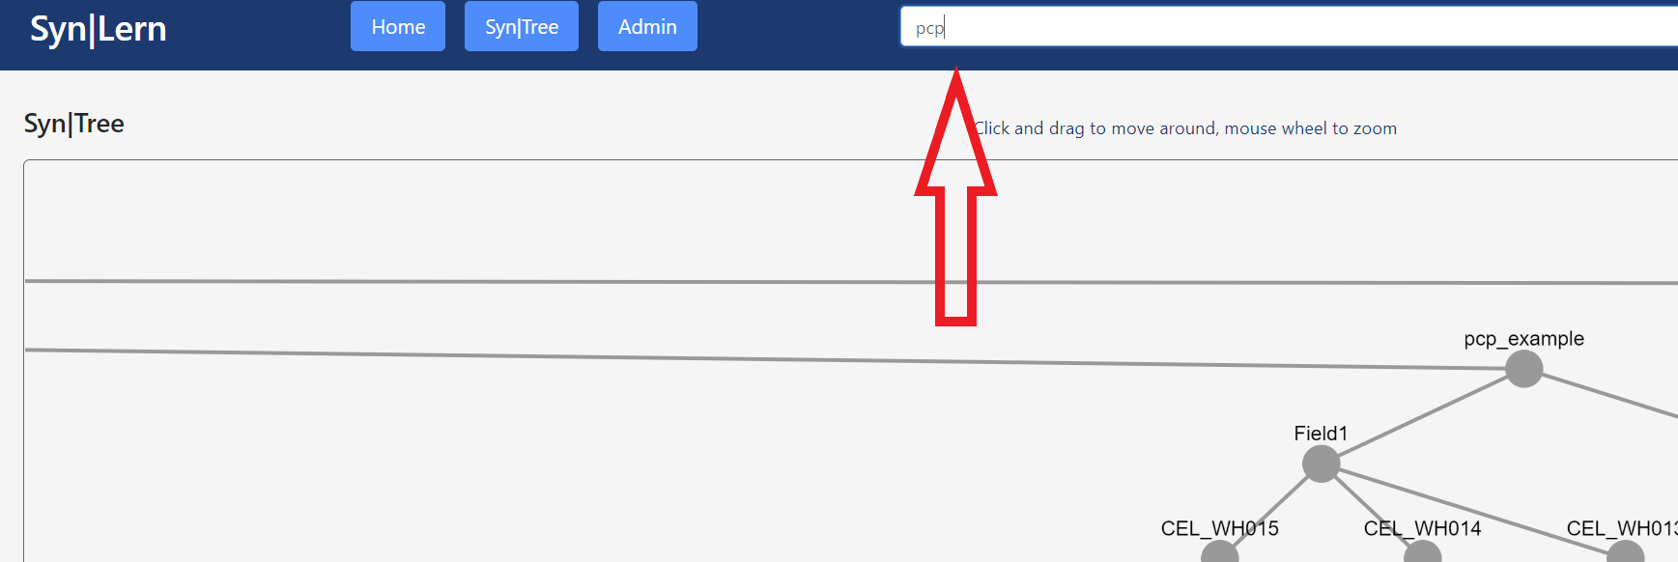

Browse results of topics and quizzes available.

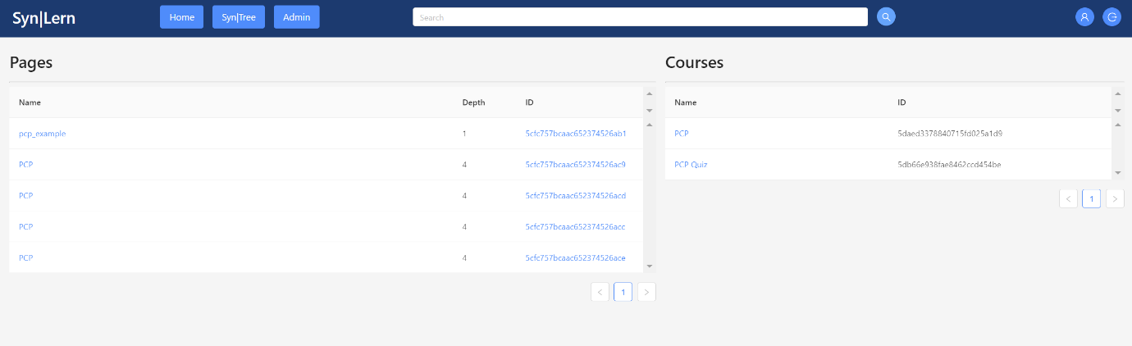

### Adding Content and Quizzes:

In the “Admin” tab.

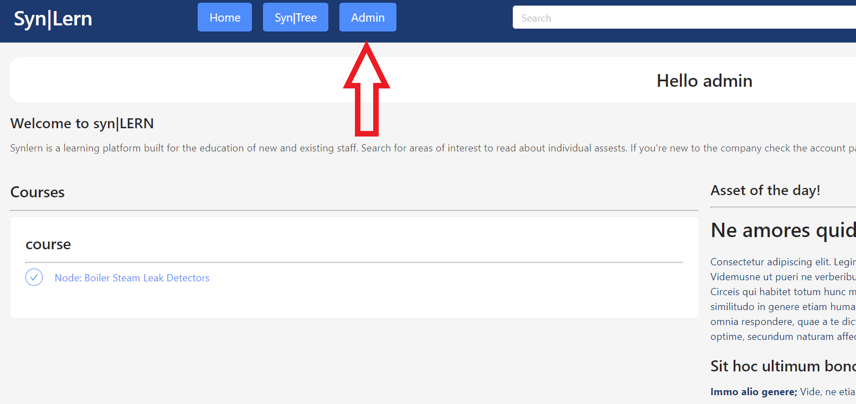

To add content, after a search result returns a topic node, select the topics’ “ID”…

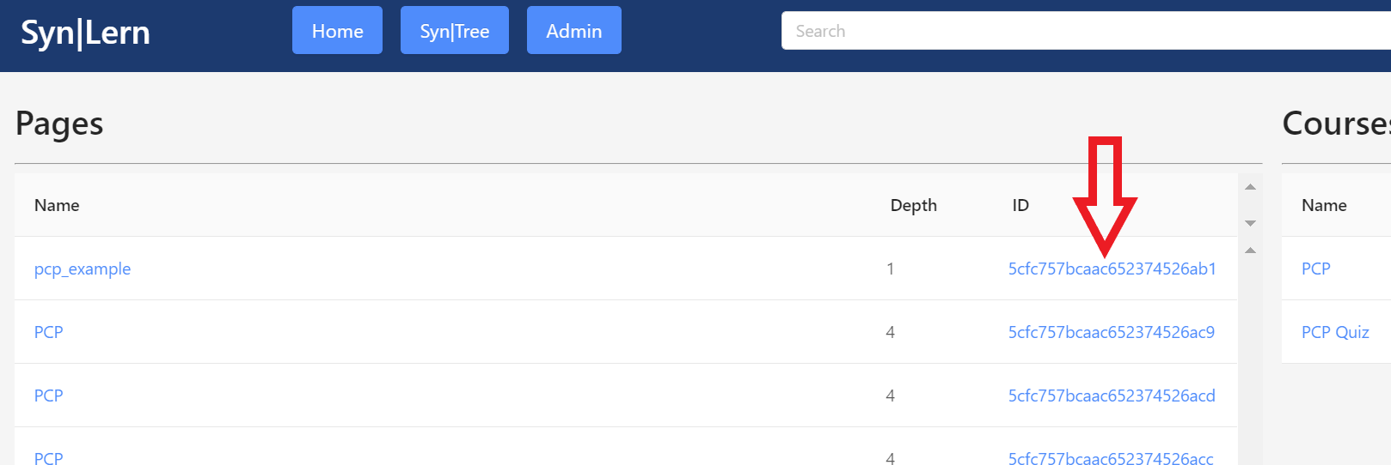

Then selecting “Page Builder”, to add content. Add a quiz to the topic node by selecting “Course Builder”.

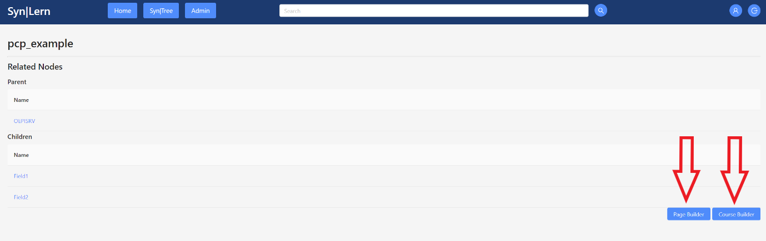

To add a quiz in “Course Builder” select the “+” symbol. Then “>” symbol.

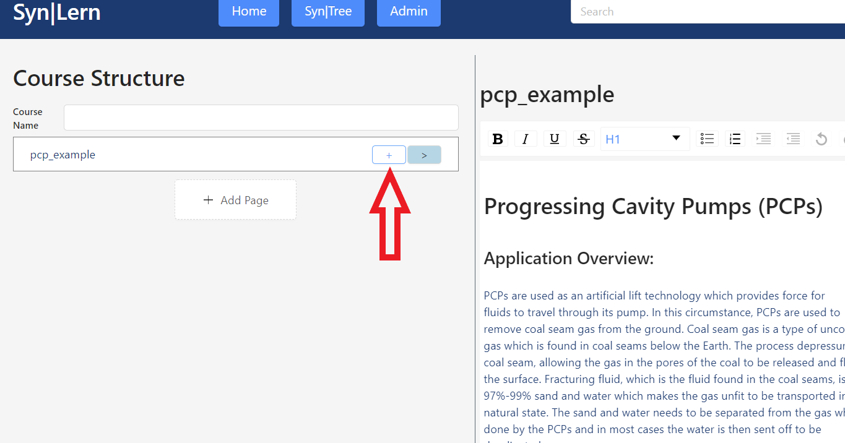

Be sure to fill out all fields and don’t forget to save!

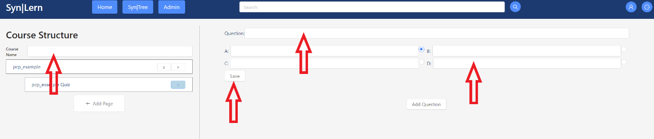

### Manage/Direct/Monitor Users:

Select “Admin” tab.



By selecting a user’s “Edit” option…

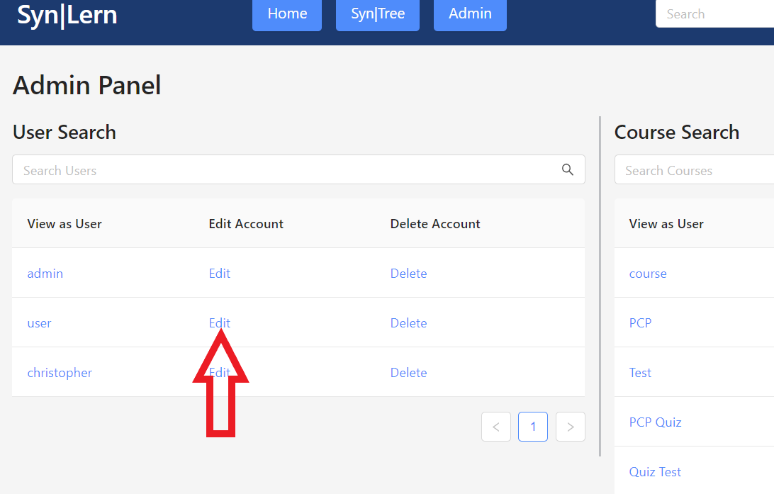

…an Admin may direct a user to take a quiz, remove a quiz, change the access level of a user, change user details and view courses completed. Users can be removed from the above panel.

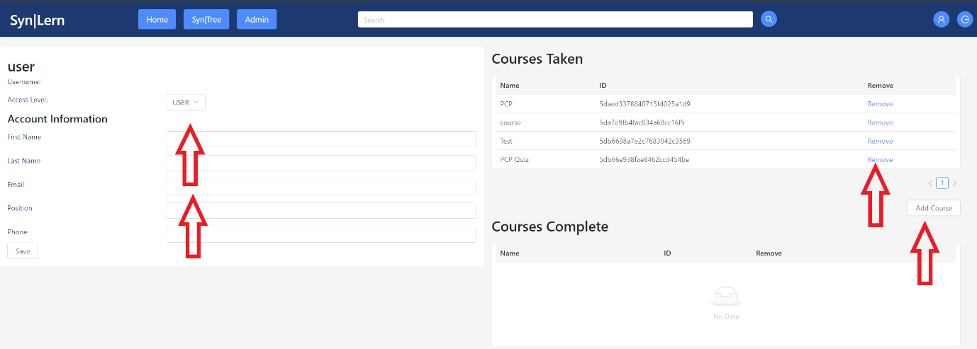

### User Functions:

### Create an account:



For new users select “register now!”.



Add user name and password and click “Create User”.

### Searching:

Select “Syn|Tree”, navigate node tree using left muse click and scroll wheel, to find a node (or topic) of interest.



Enter topic into search bar.



Browse results of topics and quizzes available.



### Doing Quizzes:

On the users “Home” page you may search for a topic in the nav bar or via the “Syn|Tree” tab. Also a user may view courses and quizzes assigned to the user in the “Courses” section.

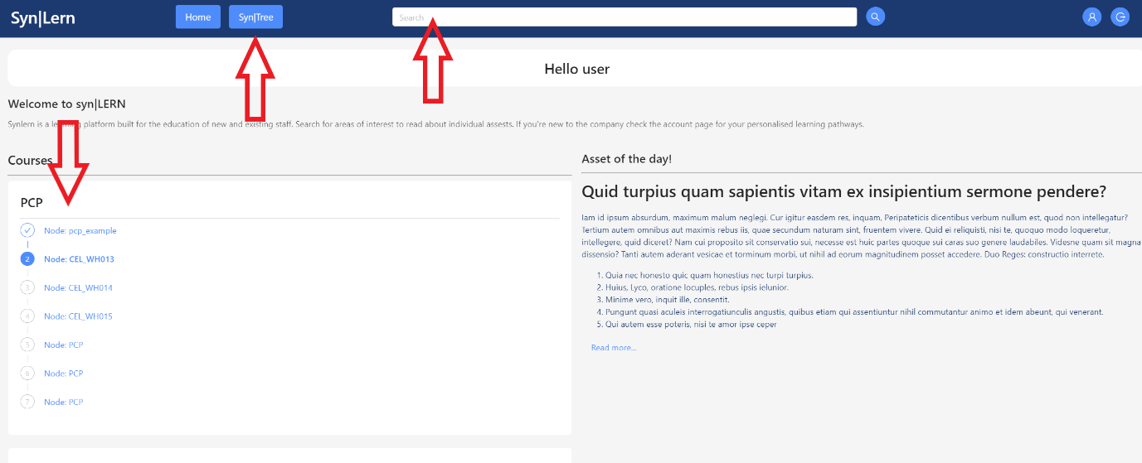

To take a quiz on relevant topics and hardware select the quiz heading.

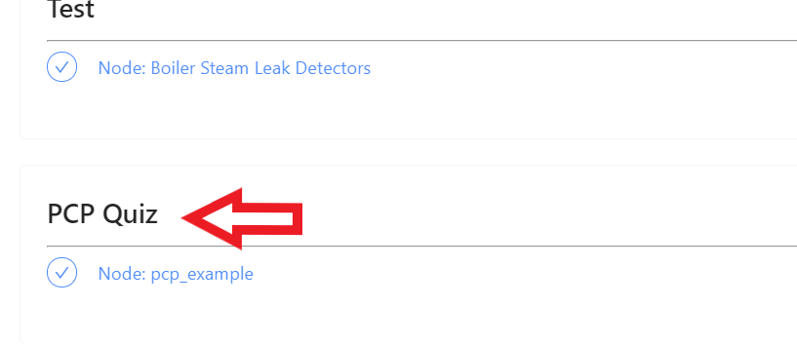

After studying the content select the “>” symbol.

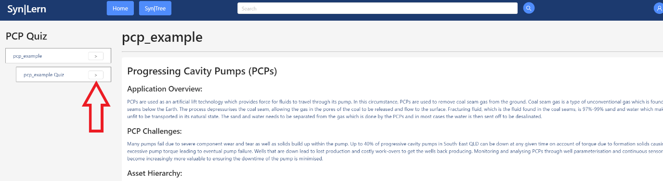

Proceed to take the quiz!

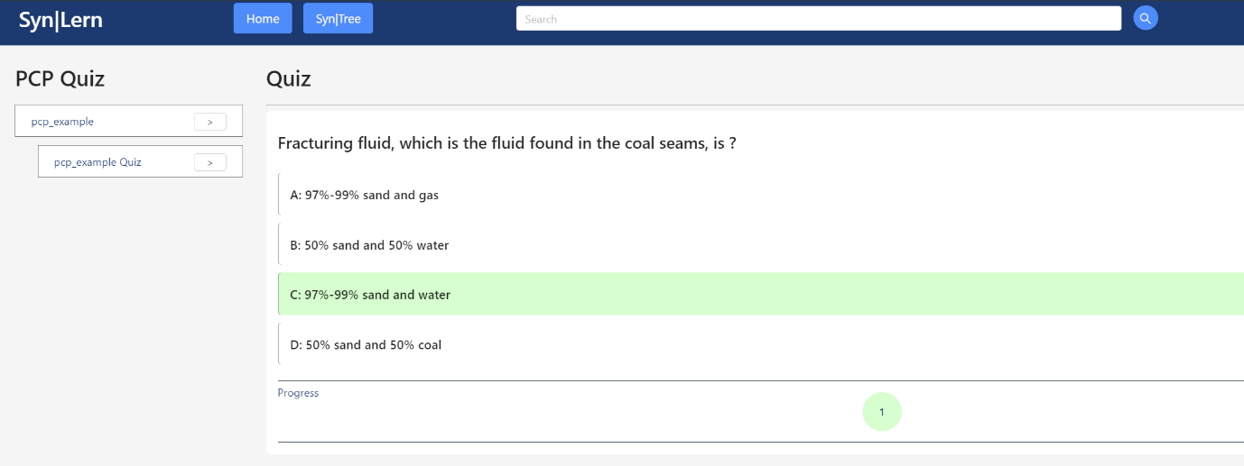

### Adding with Comments:

Users may interact socially in comment sections, in content pages, as well as add relevant information to content.

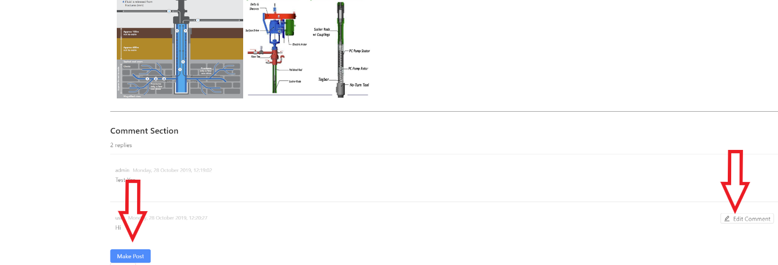

Thank you for using Syn|LERN.

### Tech Support Contact:

Jonn Dillon

Email: [jonn_dillon@iinet.net.au](mailto:jonn_dillon@iinet.net.au)

Phone: 0404514510